|  |  |  |
| --- | --- | --- |
| **SlNo.** | **Title** | **Page No.** |
| 1 | Introduction | 2 |
| 2 | Problem Definition and Design Thinking | 2 |
| 3 | Result | 6 |
| 4 | Advantages and Disadvantages | 7 |
| 5 | Applications | 8 |
| 6 | Future scope | 9 |
| 7 | Conclusion | 10 |
| 8 | Appendix | 10 |

**Plugging into the Future: An Exploration of Electricity Consumption Patterns.**

**Project Report**

**1.** **Introduction :**

**Overview :**

The most important figure in the energy balance of India is the total consumption of 1.229 trillion kWh of electric energy per year. Per capita this is an average of 862 kWh.

India could be self-sufficient with domestically produced energy. The total production of all electric energy producing facilities is 1.5 tn kWh, which is 122 percent of the country's own usage. Despite this, India trades energy with foreign countries. Along with pure consumption, the production, imports and exports play an important role. Other energy sources, such as natural gas or crude oil are also used.

**Purpose :**

India is the third largest producer of electricity in the world. During the fiscal year (FY) 2019-20, the total electricity generation in the country was 1,719 TWh, of which 1,484 TWh was generated by utilities. The gross electricity consumption per capita in FY2019 was 1,208 kWh.

1. **Problem definition and Design Thinking :**

To find the Electrical energy consumption of the customer in India by analysing the regional wise and year wise consumptions.

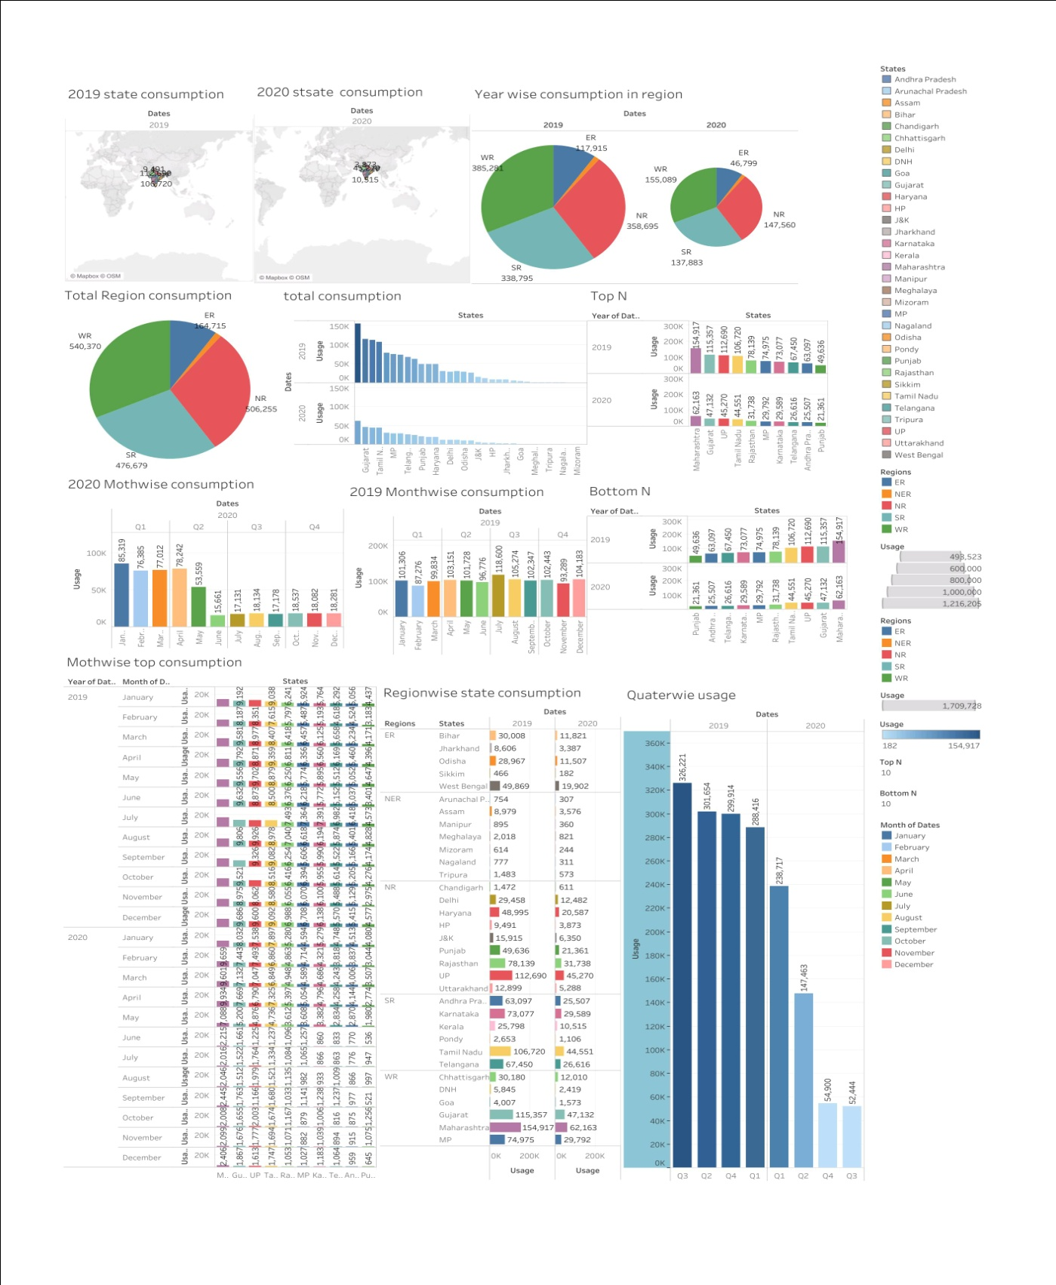**DASHBOARD 1**

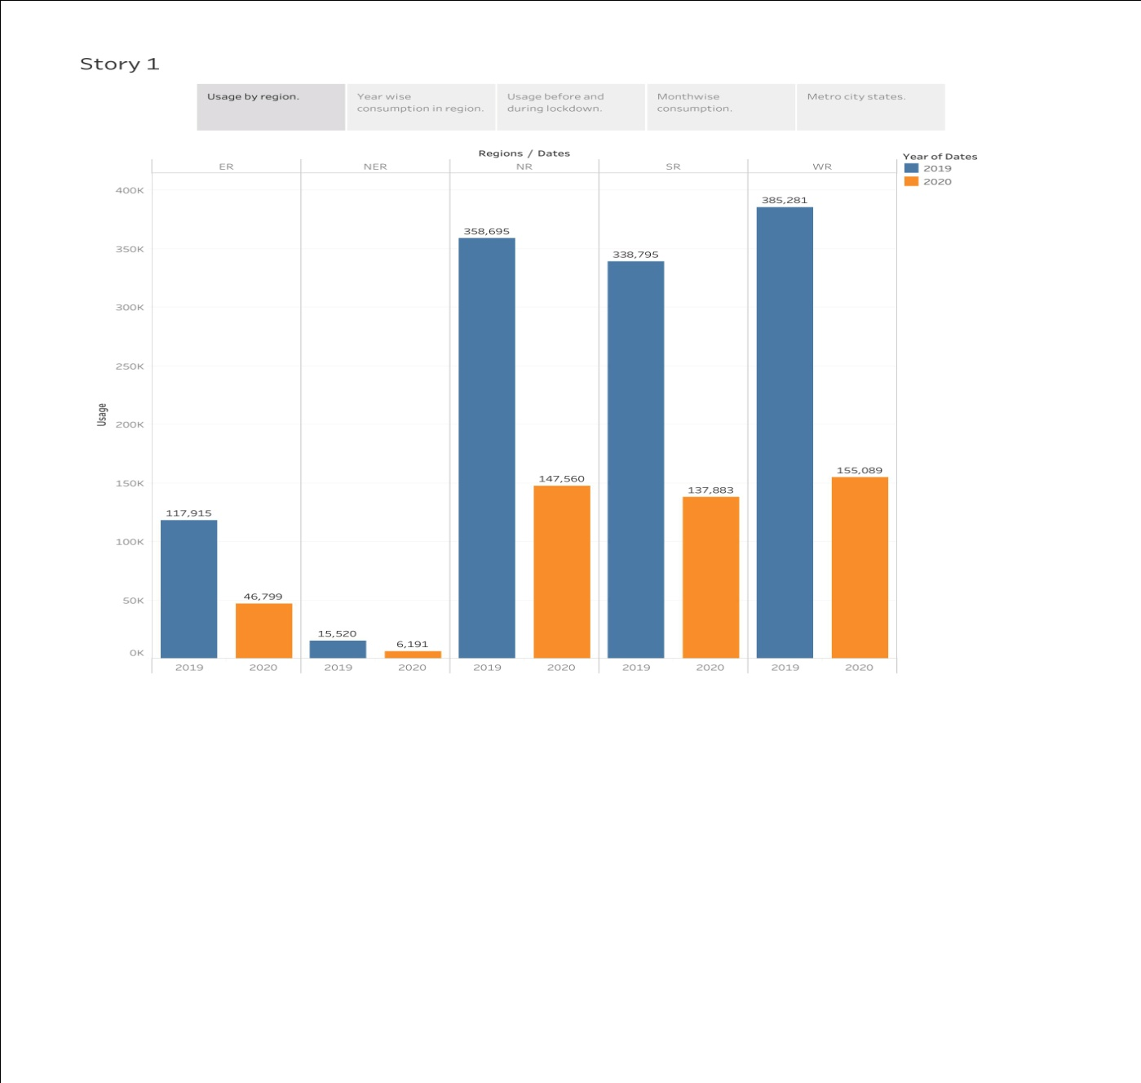**STORY**

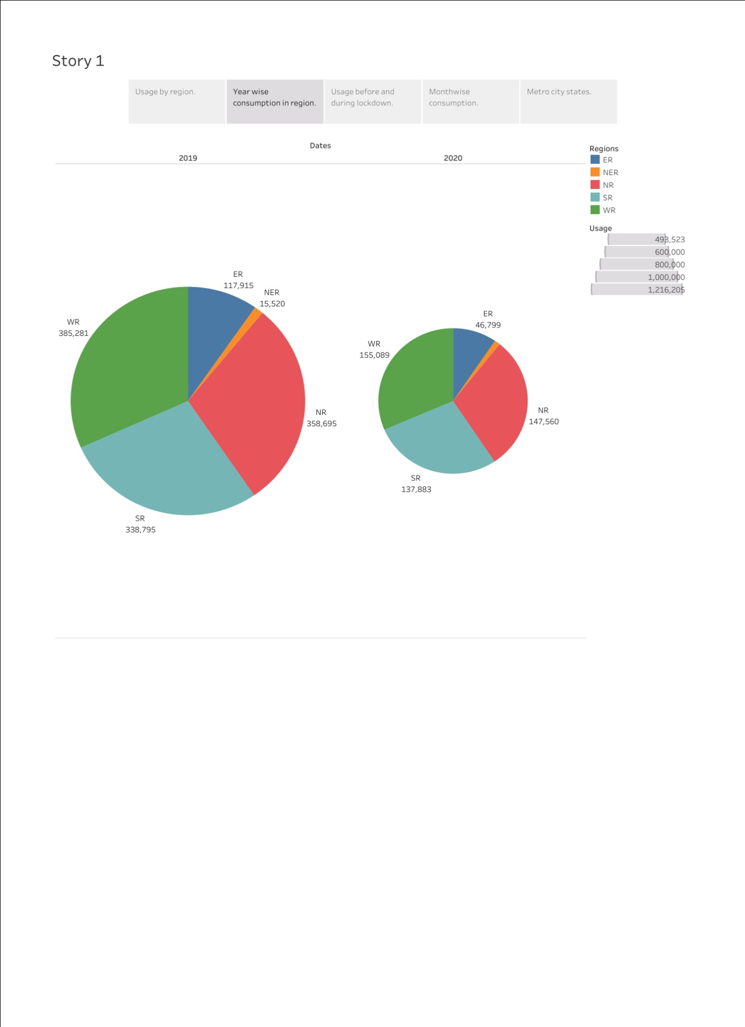

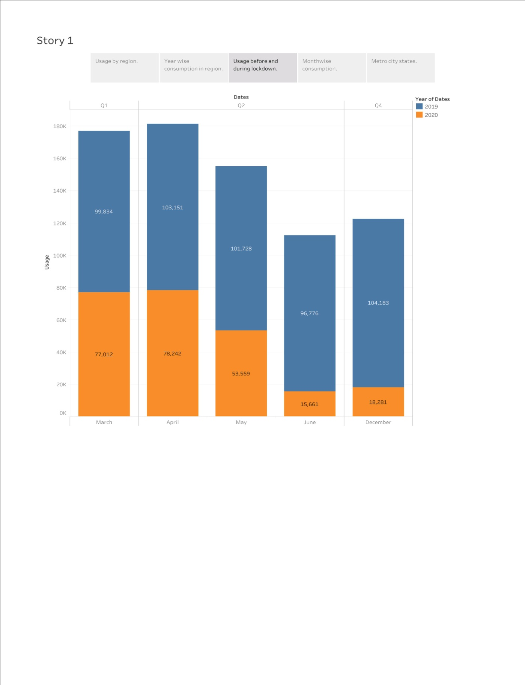

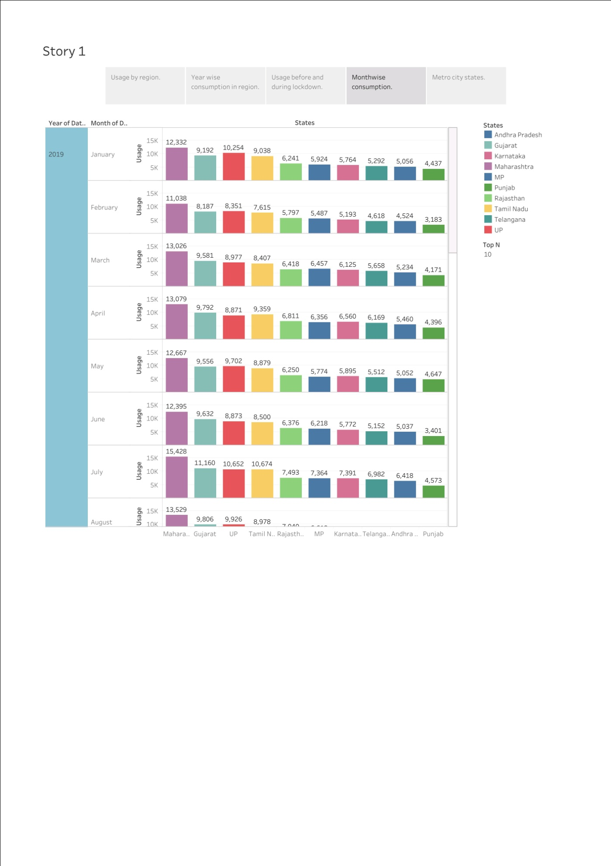**RESULT**

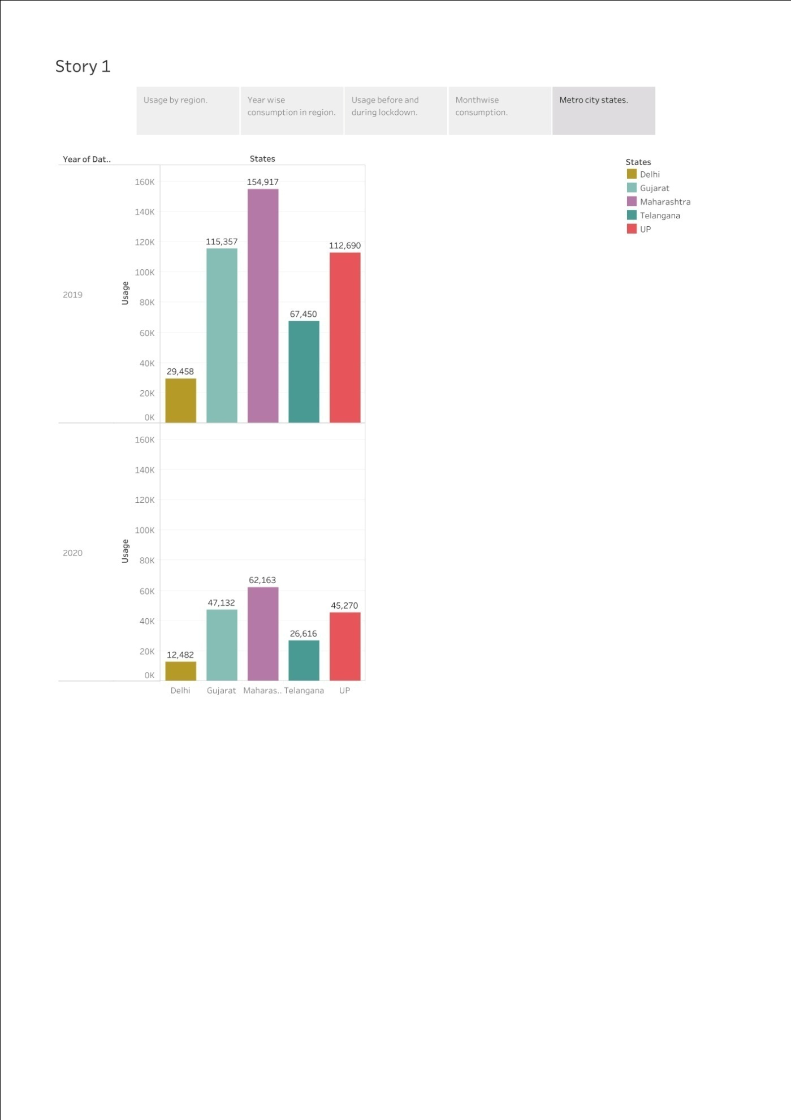

**ADVANTAGES AND DISADVANTAGES :**

**Advantages :**

1. It is a clean safe and cheap convenient source of energy.
2. It has lower maintenance cost.
3. We all know that it can be set up in many sizes.
4. It doesn’t required as many employees.
5. Reduces green house emission.
6. Makes barely any pollution compare to other ways of creating or generating electricity.
7. Hydro electric station are inexpensive to operate.
8. Hydro electricity produces no gas emission or waste.
9. A station can operate and run for long period of time.
10. It is renewable.

**Disadvantages :**

**Disadvantages of electricity:**

• More expensive than gasoline

• Loss of fish species

Sometimes messes up wildlife

Dependent on precipitation

• More power plants and more pollution

Damming can cause loss of land suitable for agriculture as well as recreation

Cost for construction

Change in river or stream quality

An electric vehicle is not completely emission free

In electricity, there are a limited number of feasible sites for a large number of dams

• Drought can affect power production

Hydroelectric natural seasonal changes in river and ecosystems can be destroyed

**APPLICATIONS:**

Energy is a very important natural resources. It should be saved because it's not at all free. Energy conservation is the effort made by us to reduce the consumption of energy by using less of an energy service or using renewable energy.

People use electricity for lighting, heating, cooling, and refrigeration and for operating appliances, computers, electronics, machinery, and public transportation systems.

**Future Scope :**

In the Stated Policies Scenario, globalelectricity demand grows at 2.1% per year to 2040, twice the rate of primary energy demand.

This raises electricity's share in total final energy consumption from 19% in 2019 to 24% in 2040. Electricity demand growth is set to be particularly strong in developing economies.

As the Indian government plans to increase electrification of rail-route kilometers from 40 percent presently to 77 percent by 2020, the level of electricity consumption achieved by 2030 could be 35-43 TWh, growing at 5.0-6.3 percent CAGR from 17 TWh in 2015.

Annual electricityconsumption per capita serves as an importantmeasure of a country'selectric power development.

Generally speaking, electricity consumption grows faster when the industrialization process develops quickly and goes down rapidly when industrialization is completed or near completion.

**CONCLUSION :**

Current through a given area of a conductor is the net charge that passes per unit time through the conductor. To keep up a gradual current, we must have a circuit within which an electrical phenomenon occurs from lower to higher mechanical energy.

**APPENDIX :**

**Source Code link :**

**https://www.iea.org/reports/world-energy-outlook-2019/electricity**

**Story link :**

https://public.tableau.com/views/Story_16828596772900/Story1?:language=en-GB&publish=yes&:display_count=n&:origin=viz_share_link

**Dashboard link:**

https://public.tableau.com/views/Dashboard_16828617447030/Dashboard1?:language=en-GB&publish=yes&:display_count=n&:origin=viz_share_link